Module Name: Practice Test Automation - Identification & Bug Report
Test Case ID: st_05
Webpage URL:https://practicetestautomation.com/logged-in-successfully

Scenario ID: 1a

Scenario: Login with valid credentials
Test Steps:
- Enter username
- Enter password
- Click Login
Screenshots:
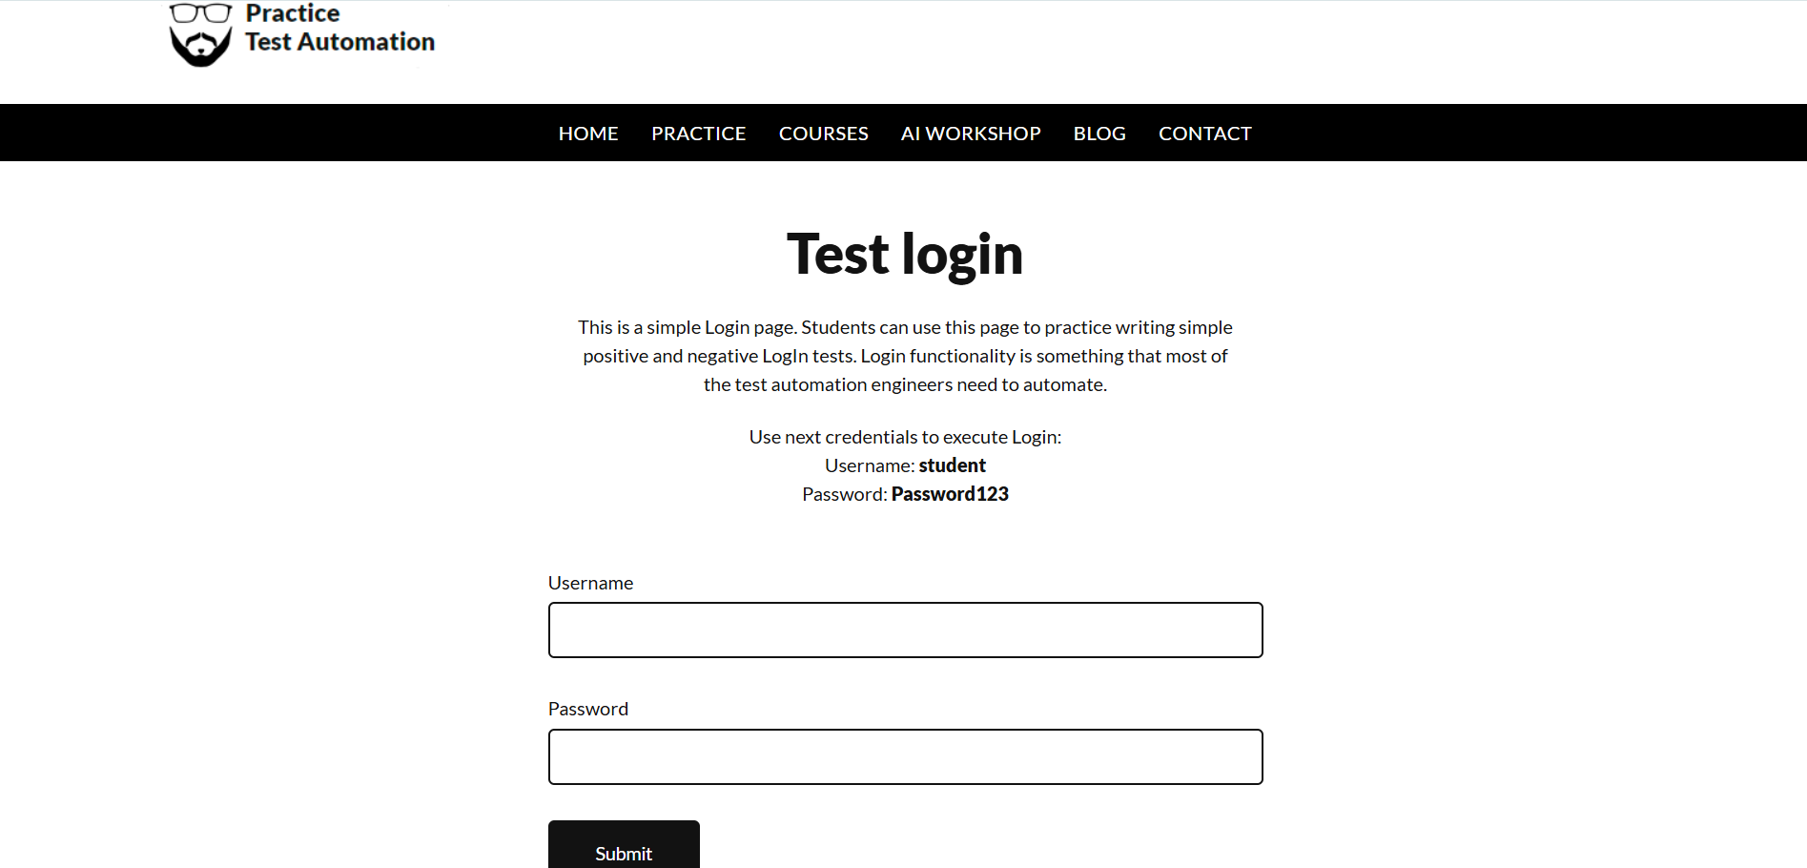
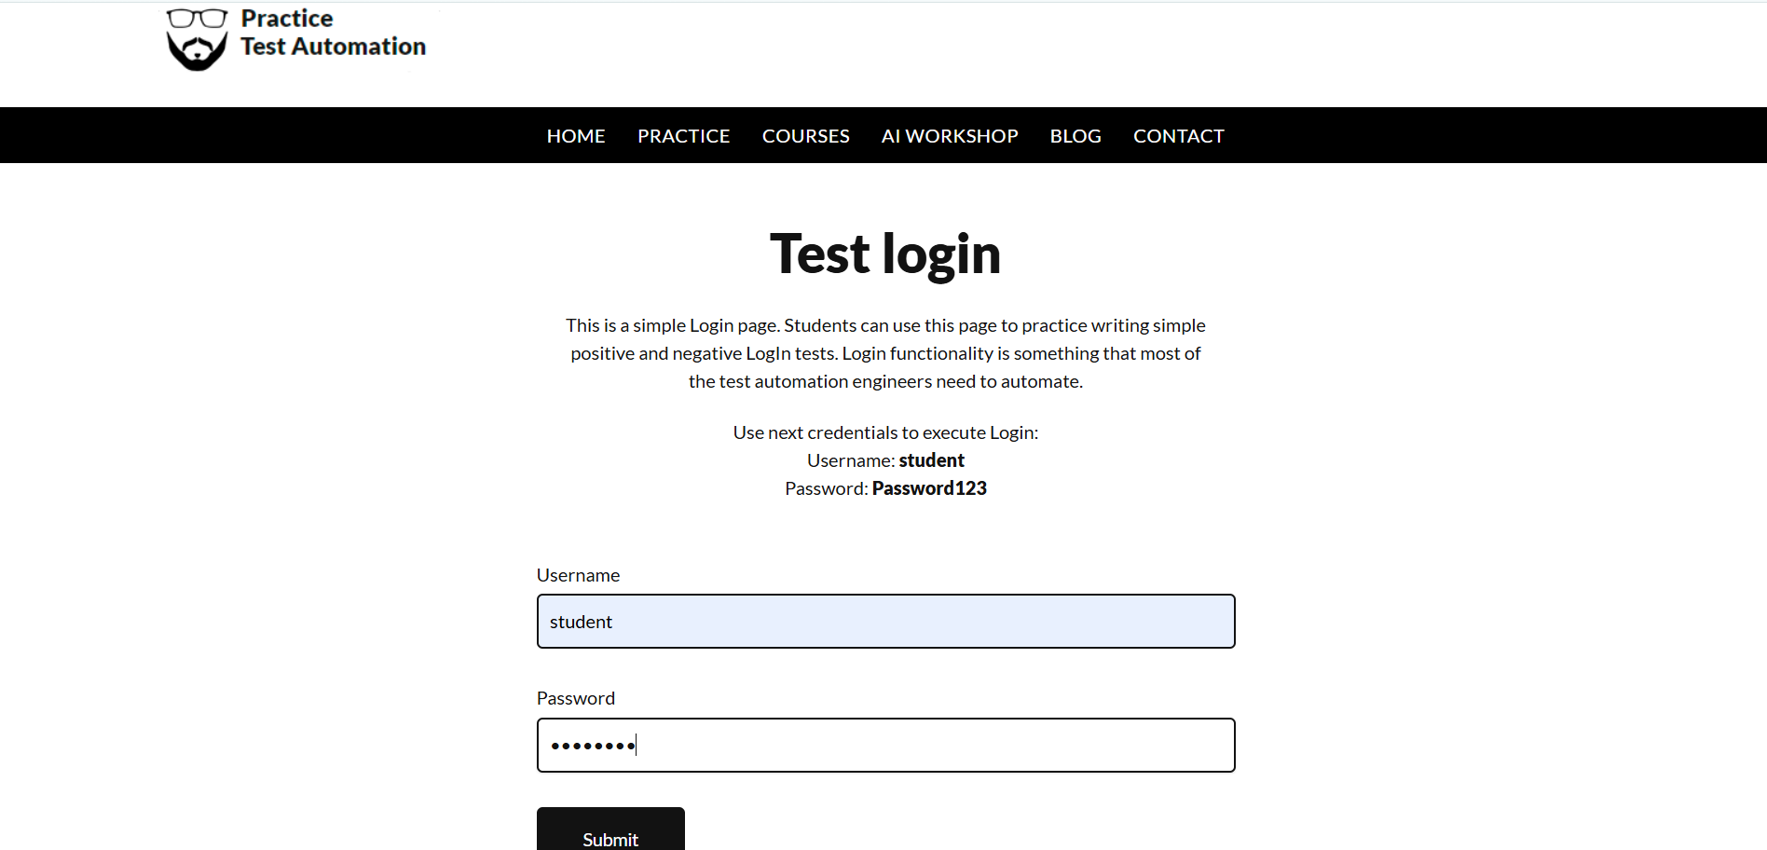
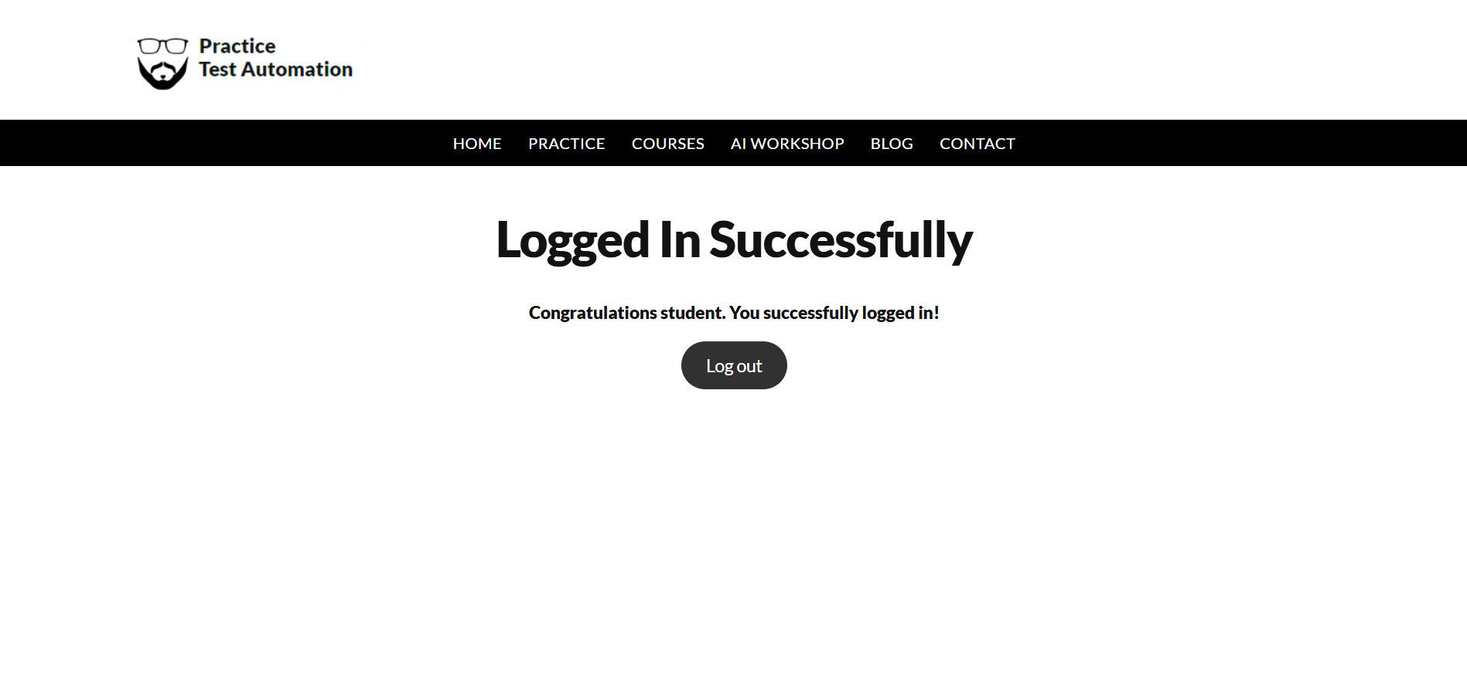
Actual Result :- Successful Login
Status:- Pass

Scenario ID: 1b

Scenario: Login with both invalid
Test Steps:
- Enter invalid username
- Enter invalid password
- Click login
Screenshots:

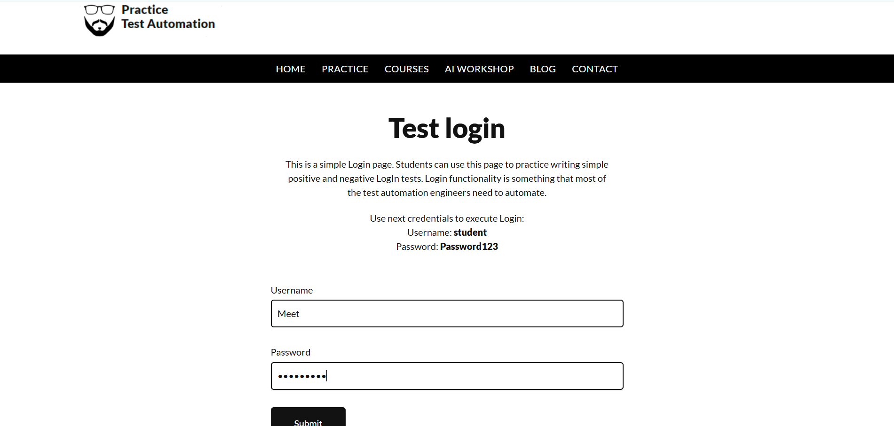
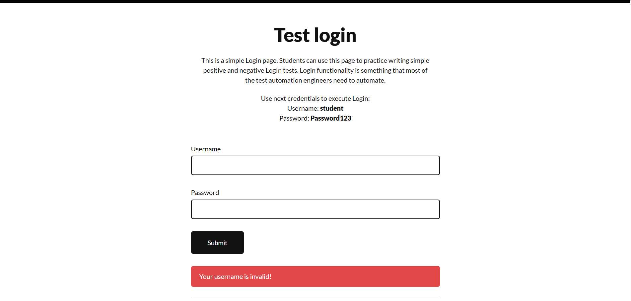

Actual Result :- Error shown
Status:- Pass

Scenario ID: 1c

Scenario: Try login with both blank
Test Steps:
- Blank username
- Blank password
- Click Login
Screenshots:
Actual Result :-Successfull Logout
Status:- Pass

Scenario ID: 2a

Scenario:View cart
Test Steps:
- Enter usename & password
- Click login
- Click courses
- Select courses
- Click Cart
Screenshots:

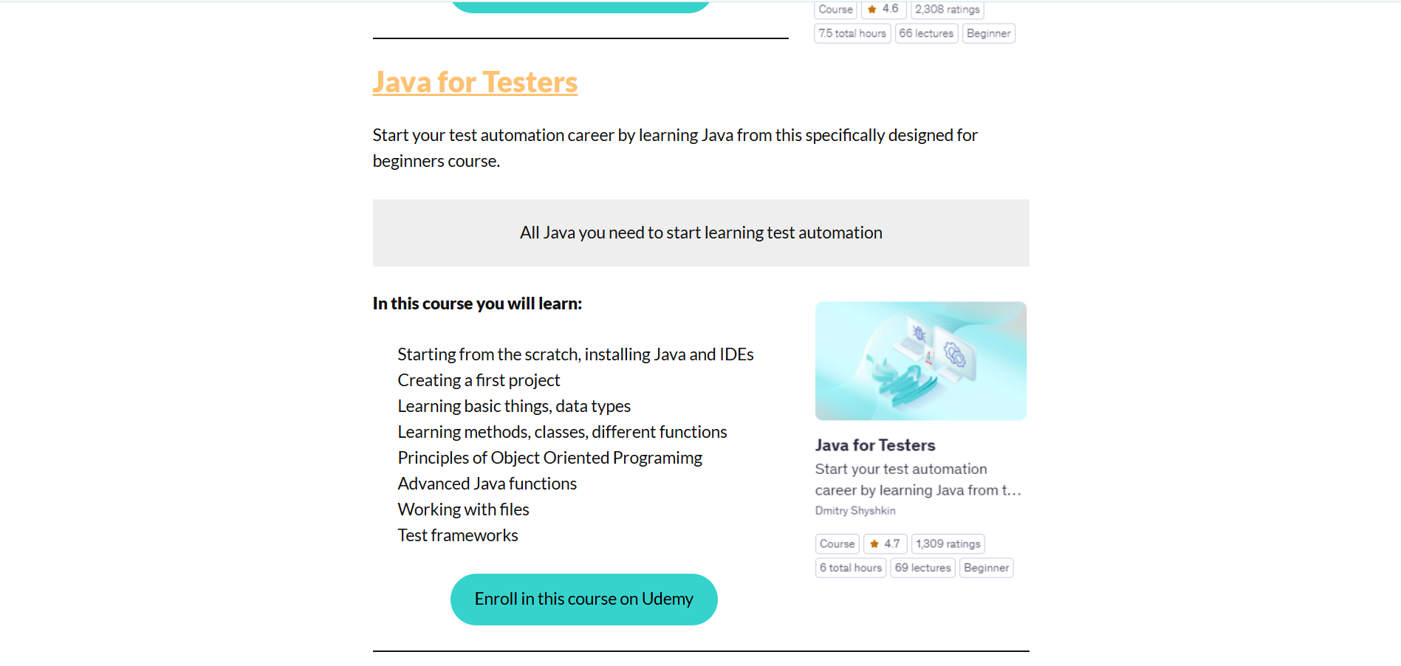

Actual Result :-Successfully view cart
Status:- Pass

Scenario ID: 2b

Scenario:Add to cart
Test Steps:
- Enter usename & password
- Click login
- Click courses
- Select courses
- Add to Cart
Screenshots:

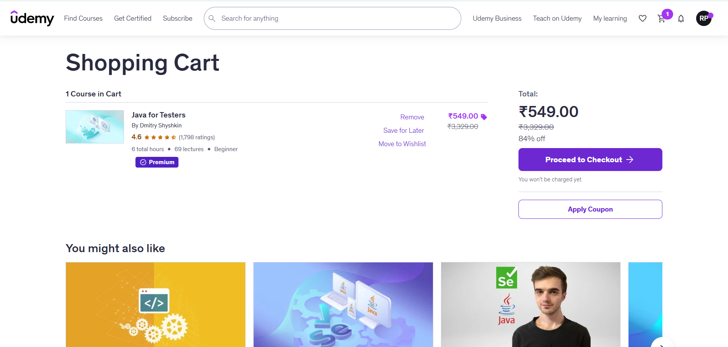

Actual Result :-Successfully Add to cart
Status:- Pass

Scenario ID: 2c

Scenario:Remove cart
Test Steps:
- Enter usename & password
- Click login
- Click courses
- Select courses
- Click Cart
- Remove Cart
Screenshots:

Actual Result :-Successfully remove to cart
Status:- Pass

Scenario ID: 2d

Scenario:Purchase courses
Test Steps:
- Enter usename & password
- Click login
- Click courses
- Select courses
- Purchase courses
Screenshots:
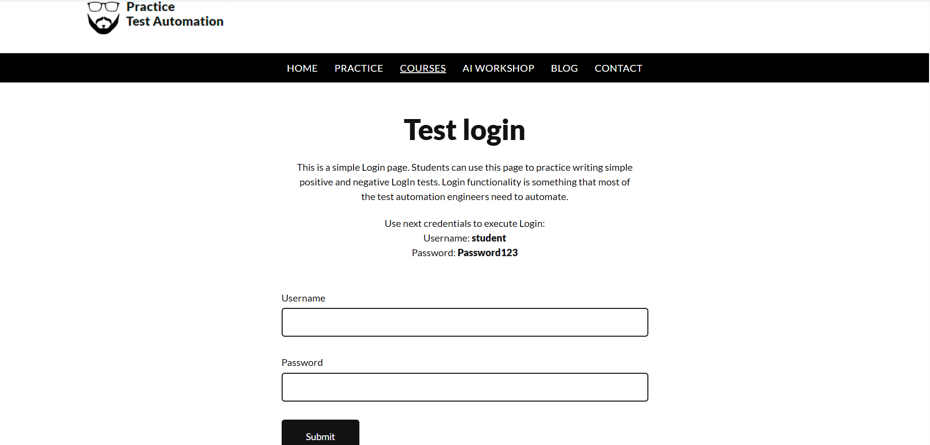

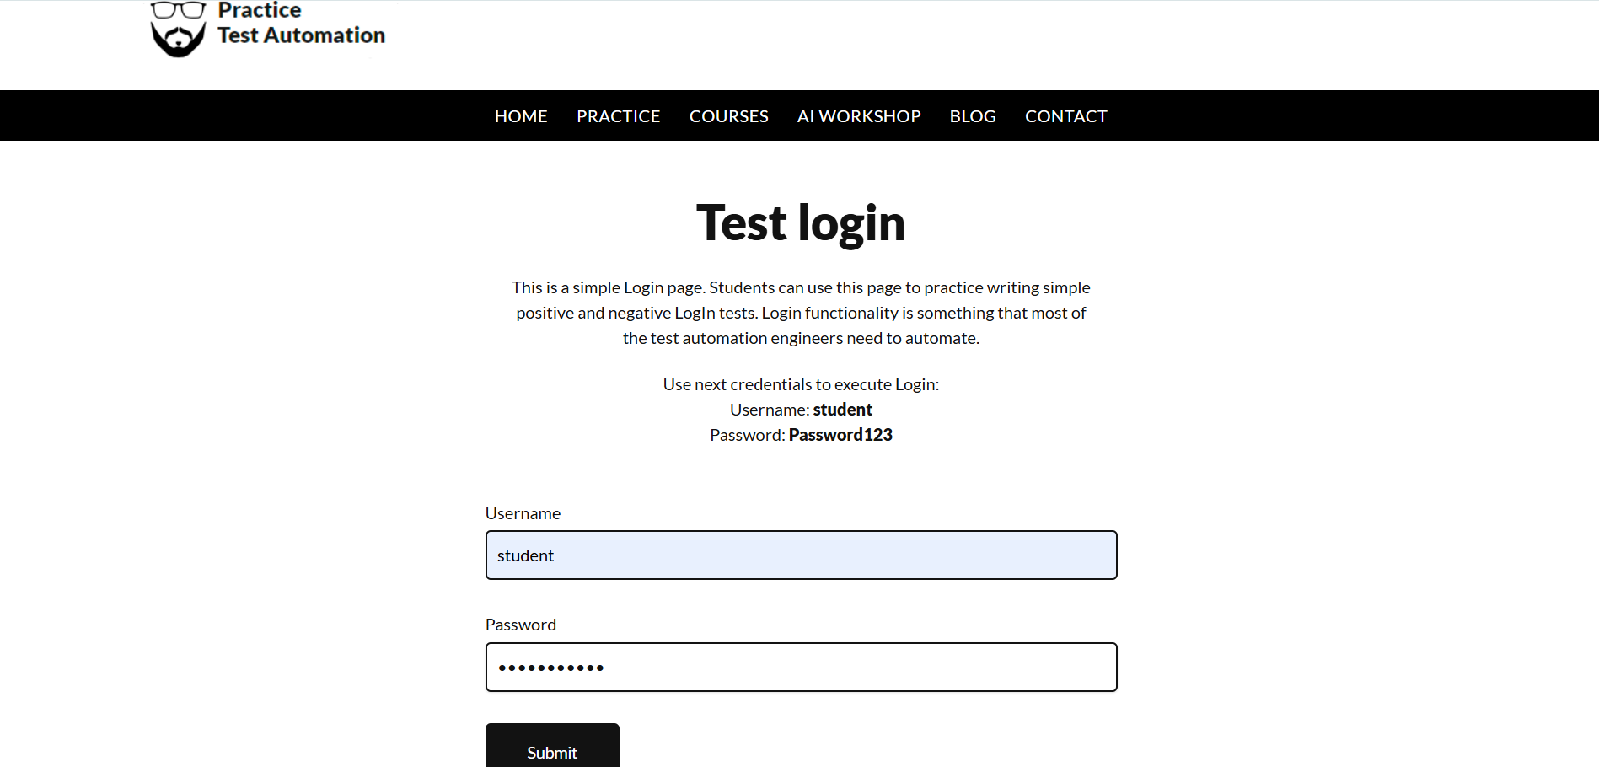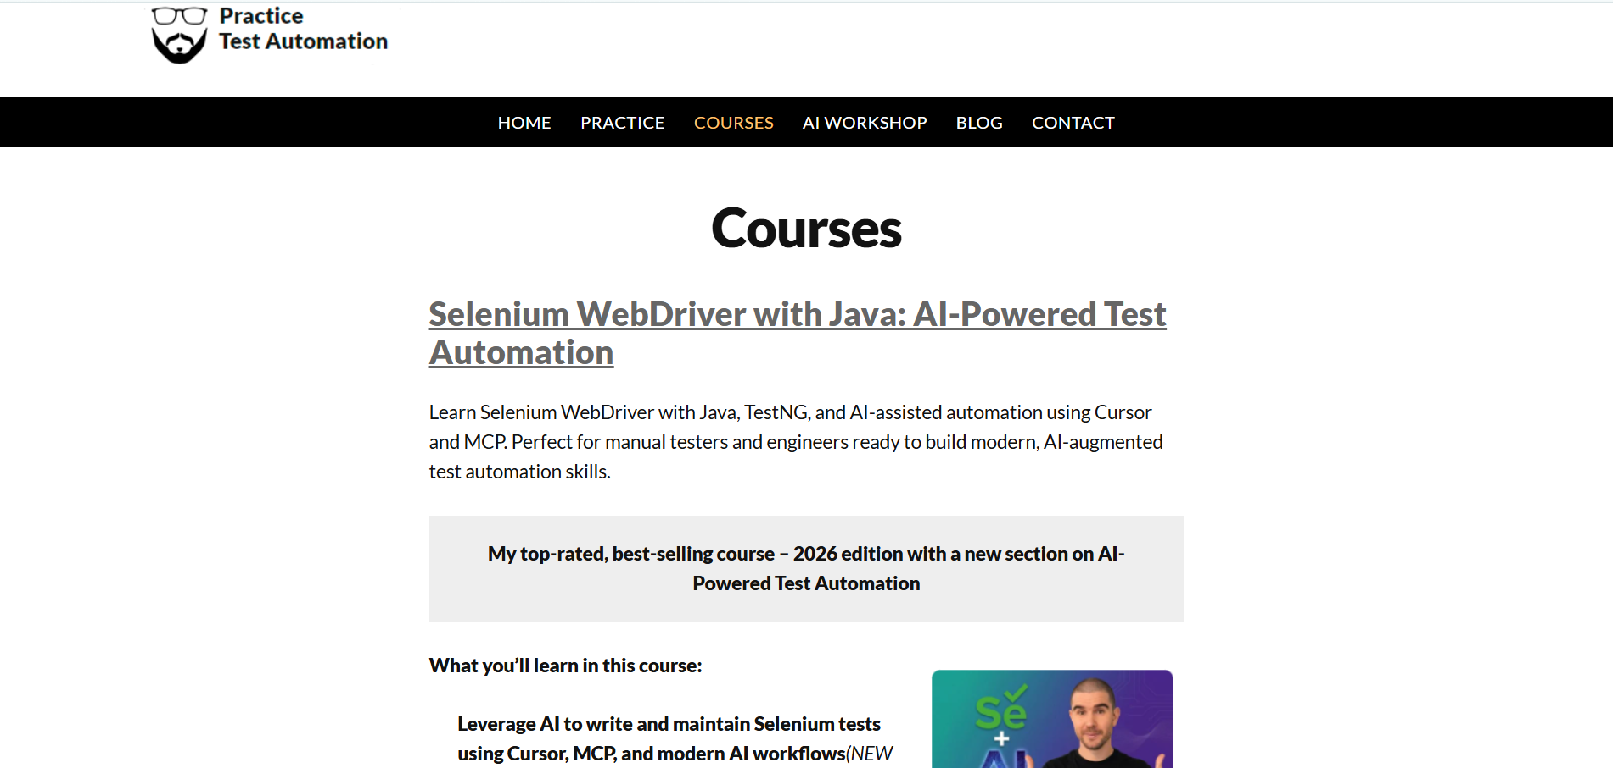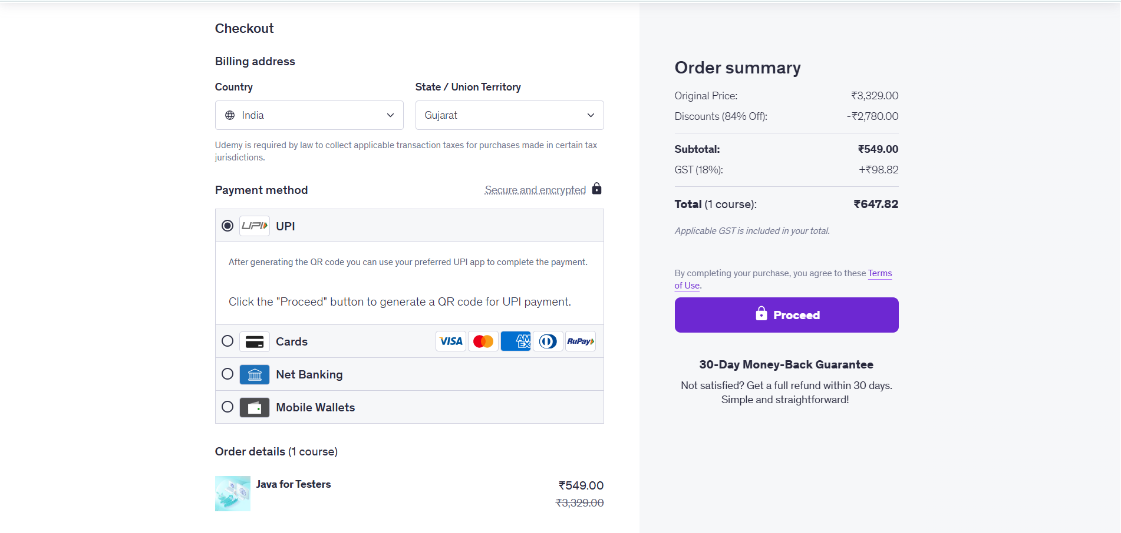

Actual Result :-Successfully purchase
Status:- Pass

Scenario ID: 3a

Scenario: Logout a website
Test Steps:
- Enter username
- Enter Password
- Click Login
- Click Logout
Screenshots:
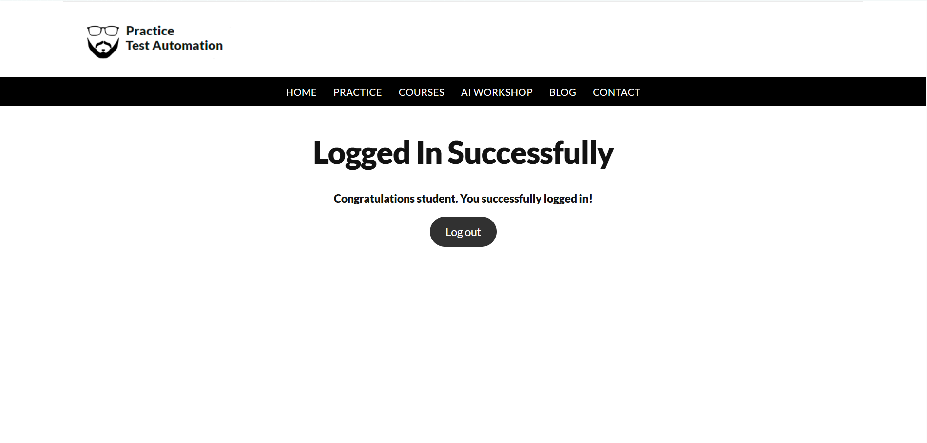

Actual Result :-Successfull Logout
Status:- Pass

